**Mineshaft Survival Pack**

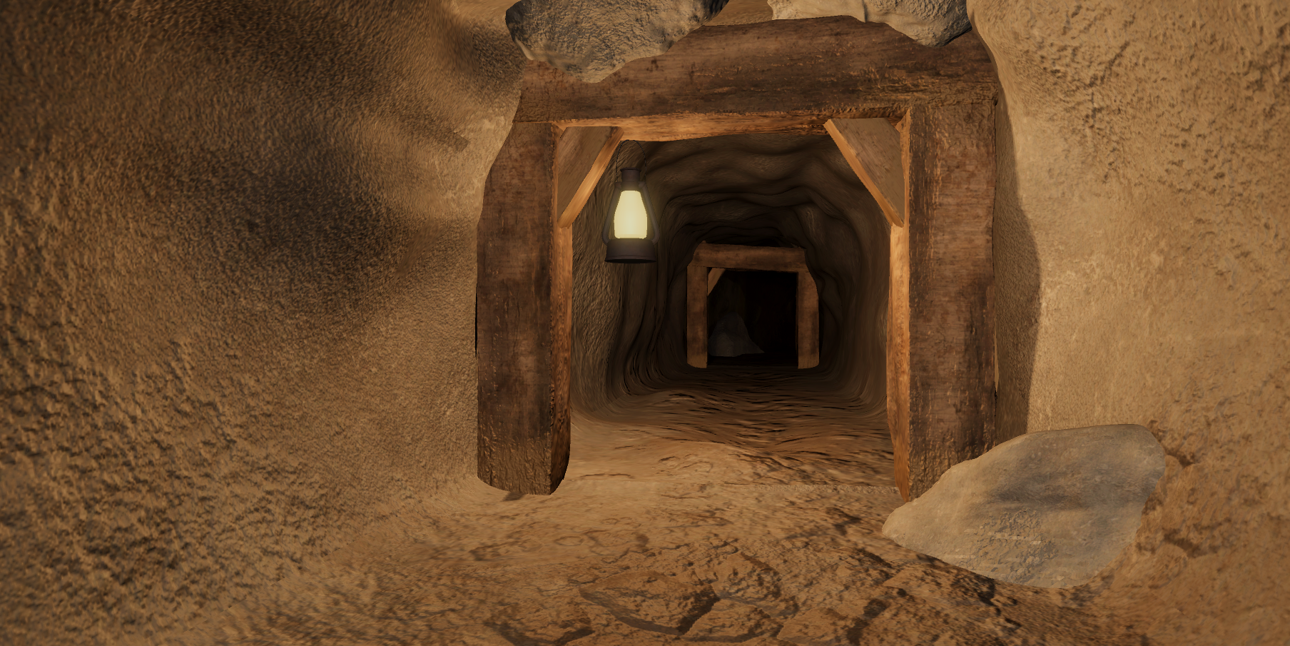

1. How to add new Food Object
2. How to add new Water Object
3. How to add new Lantern
4. How to add new AI
5. How to add new Oil/Fuel holder Object
6. How to add new Spotlights
7. How to add new Generator
8. Extra information
9. WIP Features

**Getting started:**

Setup your tags and layers to look like this

(Make sure all capital letters are CAPITAL)

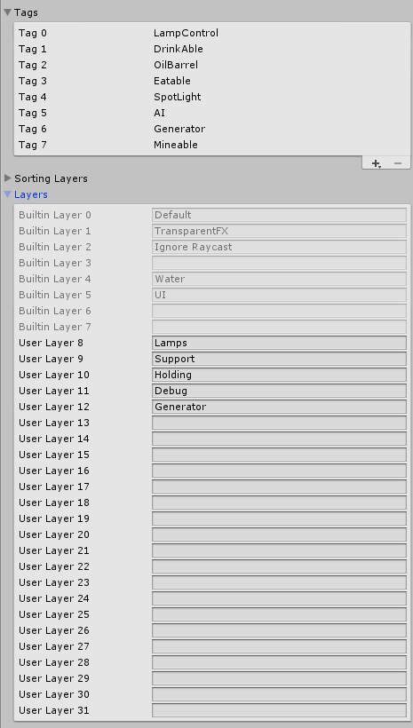

1. **Adding new Food Object**

Food objects are objects that player uses to refill his hunger and thirst bar, after player eats all of it, the model of the object will change and can be used to craft other items (Crafting coming soon)

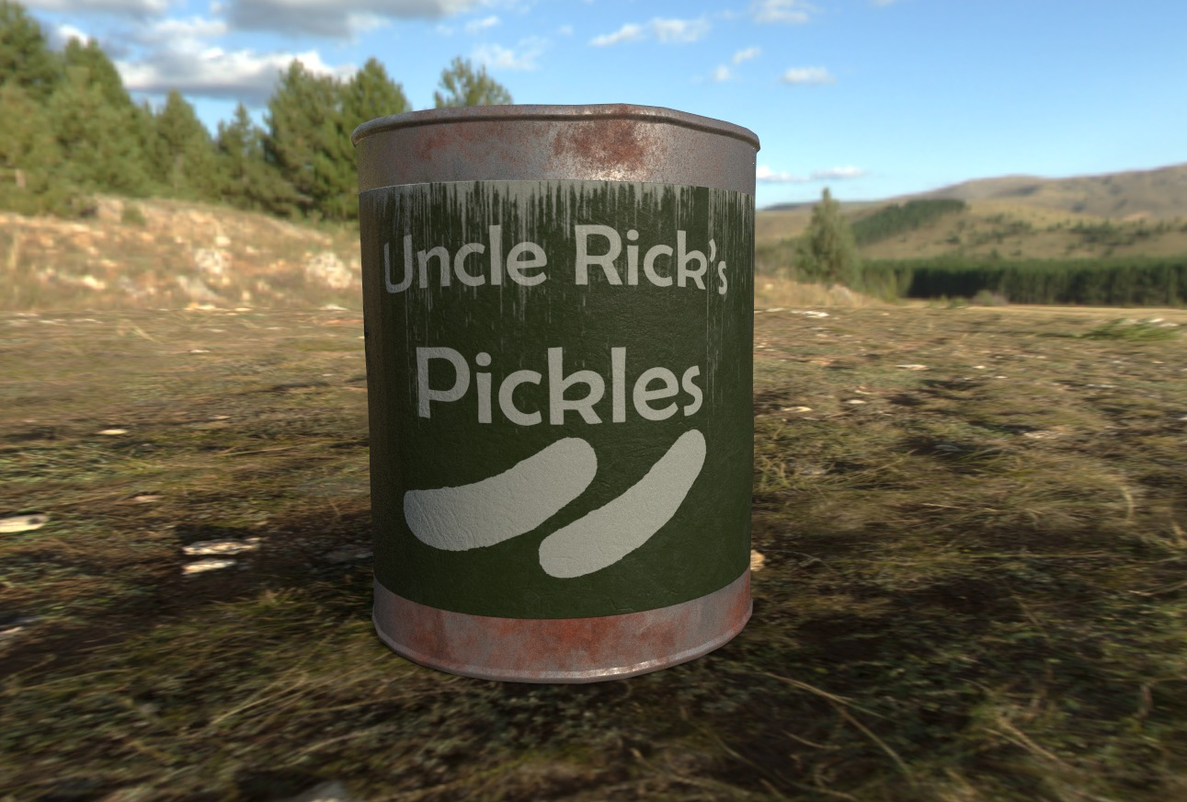

**1.**You can add new food object by dragging it into the scene (Mineshaft Survival > UsablePrefabs > FoodCan)

**2**.Now you can change Food amount to how many you want your object to hold, Change max food to maximum amount that this object can hold.

**3.** Change stats of your object:

Saturation amount = Hunger refill amount after eating

Water amount= Thirst refill amount after eating

**4.** You can change the model of the object CanEmpty is the model of the object that you get after you eat it

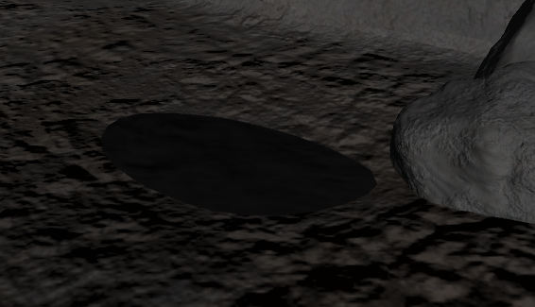**2. Adding new Water Object**

Water objects are those waters that you can find inside the caves, You can drink them and they can be set to automaticly refill them self

1. 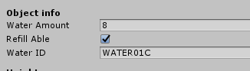 Drag Water prefab into your scene (Mineshaft Survival > UsablePrefabs > Water)
2. Change water Amount to the amout of water object currently should have
3. Refillable says if the object should refill it self after time
4. 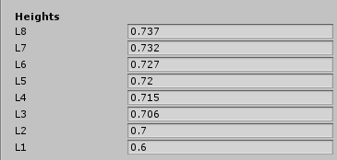Change the height values to the Y position of the object (World Scale) L8(Water Amount = 8) & L4(Water Amount = 4) etc.

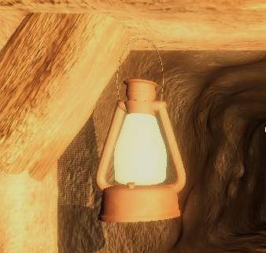**3. Adding new Lantern**

Lantern use Oil to give light, You can hang them or have them lay on the ground and be moveable by players

1. You can add lantern by dragging it into your scene (Mineshaft survival > UsablePrefabs > Lantern Swinging or Lantern Whole) Swinging lanterns cant be moved around by player, they just hang, Lantern Whole is an Rigidbody that can be moved by player
2. Change the fuel that lantern holds (max is 1000)
3. Materials are the materials that lantern has when its off/on
4. You can change the model, if you have diffirent model make sure you drag object that should change its material into the “Glass” value

**4. Adding new AI**

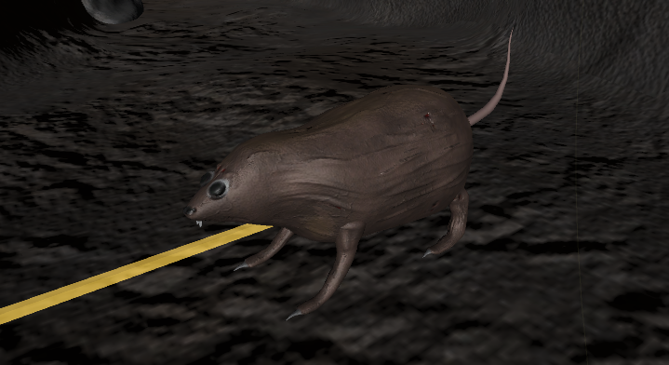AI’s can be set to be agressive or not, they will walk by them selfes by randomly generated paths, (Im working **on food** stealing script so they will steal players food)

1. Drag the “RatAi – Pack” prefab into your scene (Mineshaft survival > UsablePrefabs > RatAi – Pack)
2. Go into the RatAi and change its values like health, Damage, Attack speed and detection range to what you want
3. Agressive tag means if AI Should attack player first or be neutral until player attacks first
4. Pathfinding tag means if the AI should randomly set his own paths and walk around the caves by itself
5. You can just change rats model, make sure you drag its new model into the AI Controller > AI Obj value
6. Change its colliders if you changed the model

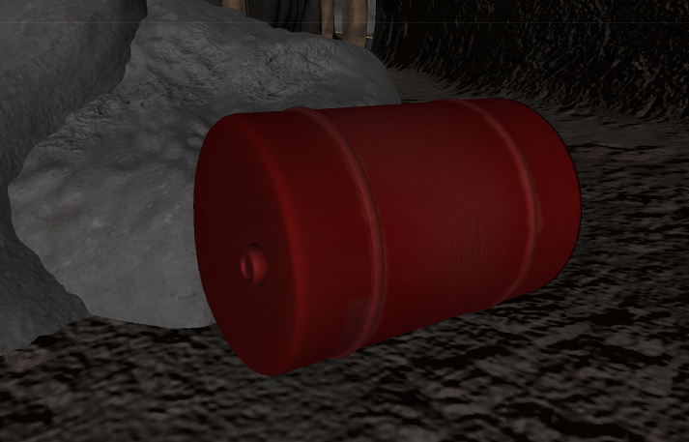**5. Adding new Oil/Fuel Holder**

Oil holders hold oil/fuel that player can use in the lanterns or generators

1. Drag the Oil Barrel or Gas can prefab into your scene (Mineshaft survival > UsablePrefabs)
2. Fuel is the amount of oil that the object currently holds
3. Max fuel is the maximum amount of the oil object can hold
4. 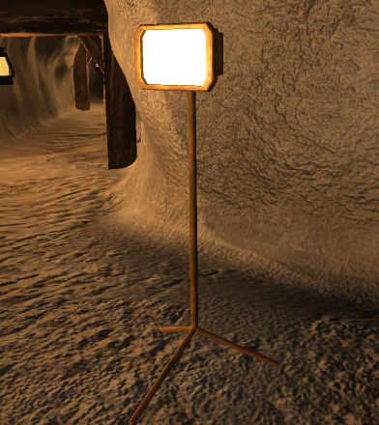**Adding new Spotlights**

Spotlights use power generated by Generators to make light, They have to be in radius of an running generator that is running

1. Drag an Spotlight prefab into your scene (Mineshaft survival > UseablePrefabs > Spotlight)
2. Spotlight > Max Distance is maximum distance between the generator and the lamp for lamp to work
3. Spotlight > Toggled is variable that means if the lamp is turned on or off
4. Spotlight > Materials and Light cube are the same as with the Lantern
5. You dont have to set the “Distance” and “Generator” variables
6. 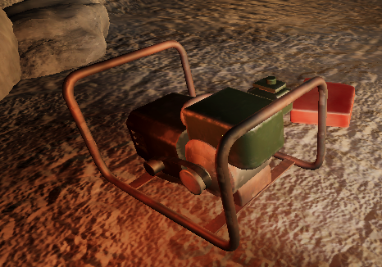**Adding new generator**

Generators generate energy that spotlights use, generators use oil/fuel to get powered and can power unlimited amount of spotlights

1. Drag an Generator into your scene (Mineshaft survival > UseablePrefabs > Generator)
2. You can change its current fuel and its maximum fuel which states how much fuel fits in the generator at once
3. You can change “visual objects” objects that get turned on when generator is running

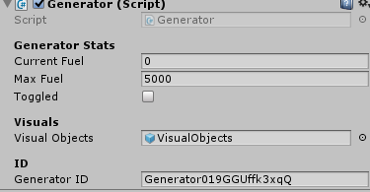

1. **Keybindings**

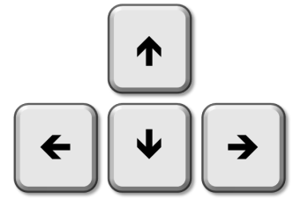

**Main actions:** E

**Refilling action:** R

**Changing items in hand:** Scroll or (1,2,3 buttons)

**Grab Object:** Hold right mouse button

**Punch:** Left mouse button

(Darker rocks are mineable using a pickaxe)

**8.Extra information**

Im very thankful for your purchase and hope that you are happy with it, If you have any suggestions or need help Im more than happy to help on my mail [Kuzkaygames@gmail.com](mailto:Kuzkaygames@gmail.com)

Feel free to message me anytime you want

1. **WIP Features**
2. AI Stealing food
3. Bigger cave system
4. Crafting using physical items
5. Weapons
6. More AI’s
7. Farming system
8. Story mode
9. Multiplayer?